16.6 Polymers
Name: ____________________ Class: ____________________ Due date: 3.15
1. 了解在Addition polymerization 中monomers 与 polymers 的官能团
Monomers：alkene polymers： alkane
1. PVA is a polymer. The monomer has the structure shown.
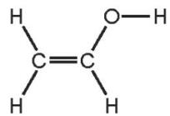
To which homologous series does this compound belong? （ ）
 | alcohols | alkenes
A | ✓ | ✓
B | ✓ | ×
C | × | ✓
D | × | ×

2. A hydrocarbon X is cracked to make Y and hydrogen. Compound Z is formed by the addition polymerisation of Y. To which homologous series do X, Y and Z belong?（ ）
 | alkane | alkene
A | X, Y and Z | -
B | X and Y | Z
C | X and Z | Y
D | Y and Z | X

4. Which row describes the formation of a polymer? （ ）
 | monomer | polymer
A | ethane | poly(ethane)
B | ethane | poly(ethene)
C | ethene | poly(ethane)
D | ethene | poly(ethene)

2. 了解在常见polymers中哪些是天然的，哪些是人工合成的。
Natural polymers: 1. Proteins 2. Carbohydrates
Synthetic polymers: 1 Nylon 2. Terylene
1. Which polymers or types of polymer are synthetic? （ ）
1carbohydrates
2nylon
3proteins
4Terylene
A.1 and 3 B.1 and 4 C.2 and 3 D.2 and 4
2. Which polymer is a synthetic polyamide? （ ）
A.nylon B.poly(ethene) C.protein D.Terylene

3. Naturally occurring polyamides are constituents of food.
i.State the name given to naturally occurring polyamides.
.........................................................................................................................[1]
ii.Name the monomers which form naturally occurring polyamides.
.........................................................................................................................[1]

3. 掌握区分Addition polymerization 与 Condensing polymerization 。
1. The structure of a synthetic polymer is shown
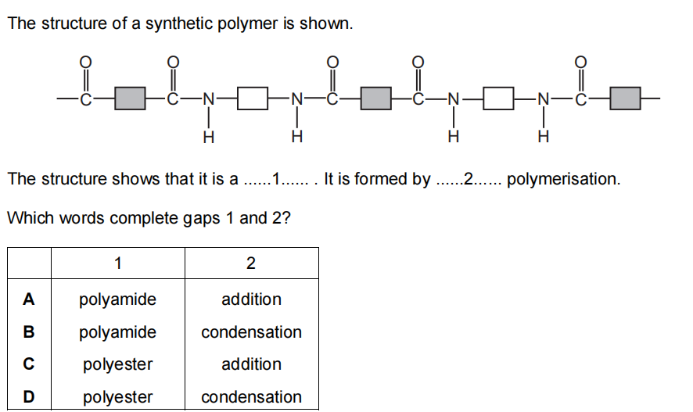
The structure shows that it is a ......1...... . It is formed by ......2...... polymerisation.
Which words complete gaps 1 and 2? （ ）

4. 掌握常见polymers的构成。
(1) Polyamide（Protien)
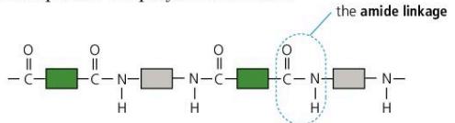
(2) Polyesters (PET)
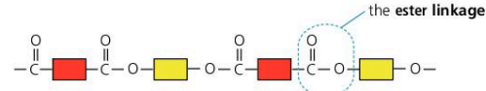
(3) Polyethene
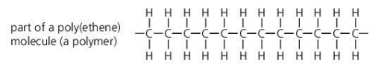
1. Which polymer structure has the same linkages as Terylene? （ ）
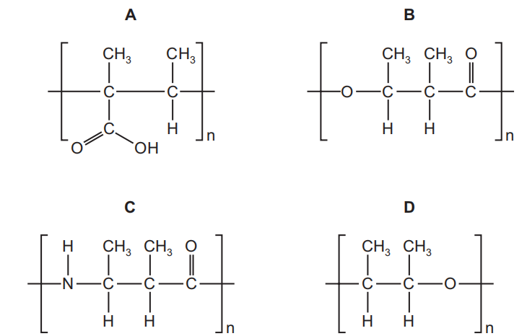
Propene is an unsaturated hydrocarbon. The formula of propene is shown.
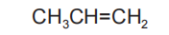
(iii) Propene can be converted into poly(propene).
Name the type of polymerisation that occurs when propene is converted into poly(propene).

(iv) Complete the diagram to show a section of poly(propene)
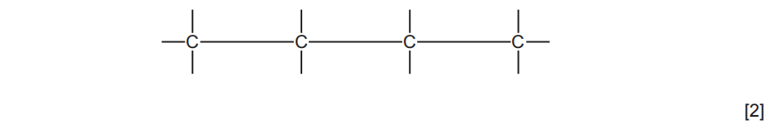
2. Part of a polyester chain is shown. This polyester is made from one monomer.
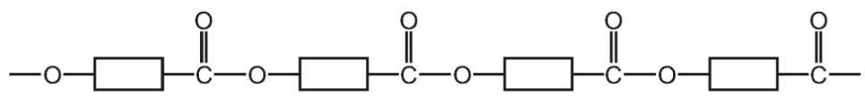
a. On the diagram draw a ring around one unit of the polymer that is repeated. [1]
b. Name the type of polymerisation that produces polyesters.
.........................................................................................................................[1]
c. Complete the diagram to show the structure of the monomer used to produce this polyester. Show all of the atoms and all of the bonds in the functional groups.
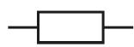
[2]
d.A polyamide is made from the two monomers shown.
Complete the diagram to show a section of the polyamide made from the two monomers. Show all of the atoms and all of the bonds in the linkages.

3.Ethene,${CH}_{2}={CH}_{2}$,and propene,${CH}_{2}={CHCH}_{3}$,can both be converted into polymers.
What type of polymerisation takes place when ethene forms a polymer?
.......................................................................................................................................
.................................................................................................................................[1]
ii.What is the empirical formula of the polymer formed from ethene?
..................................................................................................................................[1]
Propene has the structural formula ${CH}_{2}={CHCH}_{3}$ .
Draw two repeat units of the polymer made from propene.

[2]

4. This question is about polymers.
(a) Polymer X is a condensation polymer.
Part of the structure of polymer X is shown.
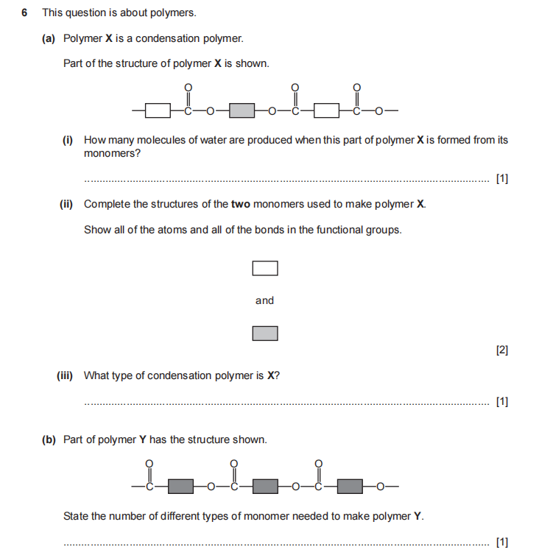
How many molecules of water are produced when this part of polymer X is formed from its monomers?
...................................................................................................................................[1]

(ii) Complete the structures of the two monomers used to make polymer X.
Show all of the atoms and all of the bonds in the functional groups.
(iii)What type of condensation polymer is X?
...................................................................................................................................[1]
(b) Part of polymer Y has the structure shown
State the number of different types of monomer needed to make polymer Y.
...................................................................................................................................[1]

